

# 

### Semester One Examination, 2017

### Question/Answer booklet

# MATHEMATICS

CARTER ROOHI 

STRAIN  CHENG 

STAFFE  SKODA 

McCLELLAND  GANNON 

**METHODS**

**UNIT 3**

## Section Two:

## Calculator-assumed

|  |  |  |  |  |  |  |  |  |  |  |
| --- | --- | --- | --- | --- | --- | --- | --- | --- | --- | --- |
| Student Number |  |  |  |  |  |  |  |  |  |  |

Your name

## Time allowed for this section

Reading time before commencing work: ten minutes

Working time: one hundred minutes

## Materials required/recommended for this section

***To be provided by the supervisor***

This Question/Answer booklet

Formula sheet (retained from Section One)

***To be provided by the candidate***

Standard items: pens (blue/black preferred), pencils (including coloured), sharpener, correction fluid/tape, eraser, ruler, highlighters

Special items: drawing instruments, templates, notes on two unfolded sheets of A4 paper, and up to three calculators approved for use in this examination

## Important note to candidates

No other items may be taken into the examination room. It is **your** responsibility to ensure that you do not have any unauthorised material. If you have any unauthorised material with you, hand it to the supervisor **before** reading any further.

## Structure of this paper

|  |  |  |  |  |  |
| --- | --- | --- | --- | --- | --- |
| Section | Number of questions available | Number of questions to be answered | Working  time (minutes) | Marks available | Percentage of examination |
| Section One:  Calculator-free | 8 | 8 | 50 | 51 | 34 |
| Section Two:  Calculator-assumed | 13 | 13 | 100 | 101 | 66 |
|  | | |  | **Total** | 100 |

## Instructions to candidates

1. The rules for the conduct of examinations are detailed in the school handbook. Sitting this examination implies that you agree to abide by these rules.

2. Write your answers in this Question/Answer booklet.

3. You must be careful to confine your response to the specific question asked and to follow any instructions that are specified to a particular question.

4. Additional working space pages at the end of this Question/Answer booklet are for planning or continuing an answer. If you use these pages, indicate at the original answer, the page number it is planned/continued on and write the question number being planned/continued on the additional working space page.

5. Show all your working clearly. Your working should be in sufficient detail to allow your answers to be checked readily and for marks to be awarded for reasoning. Incorrect answers given without supporting reasoning cannot be allocated any marks. For any question or part question worth more than two marks, valid working or justification is required to receive full marks. If you repeat any question, ensure that you cancel the answer you do not wish to have marked.

6. It is recommended that you do not use pencil, except in diagrams.

7. The Formula sheet is not to be handed in with your Question/Answer booklet.

Section Two: Calculator-assumed 66% (101 Marks)

This section has**thirteen (****13)** questions. Answer **all** questions. Write your answers in the spaces provided.

Working time: 100 minutes.

**____________________________________________________________________________________**

**Question 9 (7 marks)**

(7 marks)

The velocity graph of a moving particle is shown below.

(a) Sketch the displacement – time graph and the acceleration-time

graph on the sets of axes provided. (2+2)

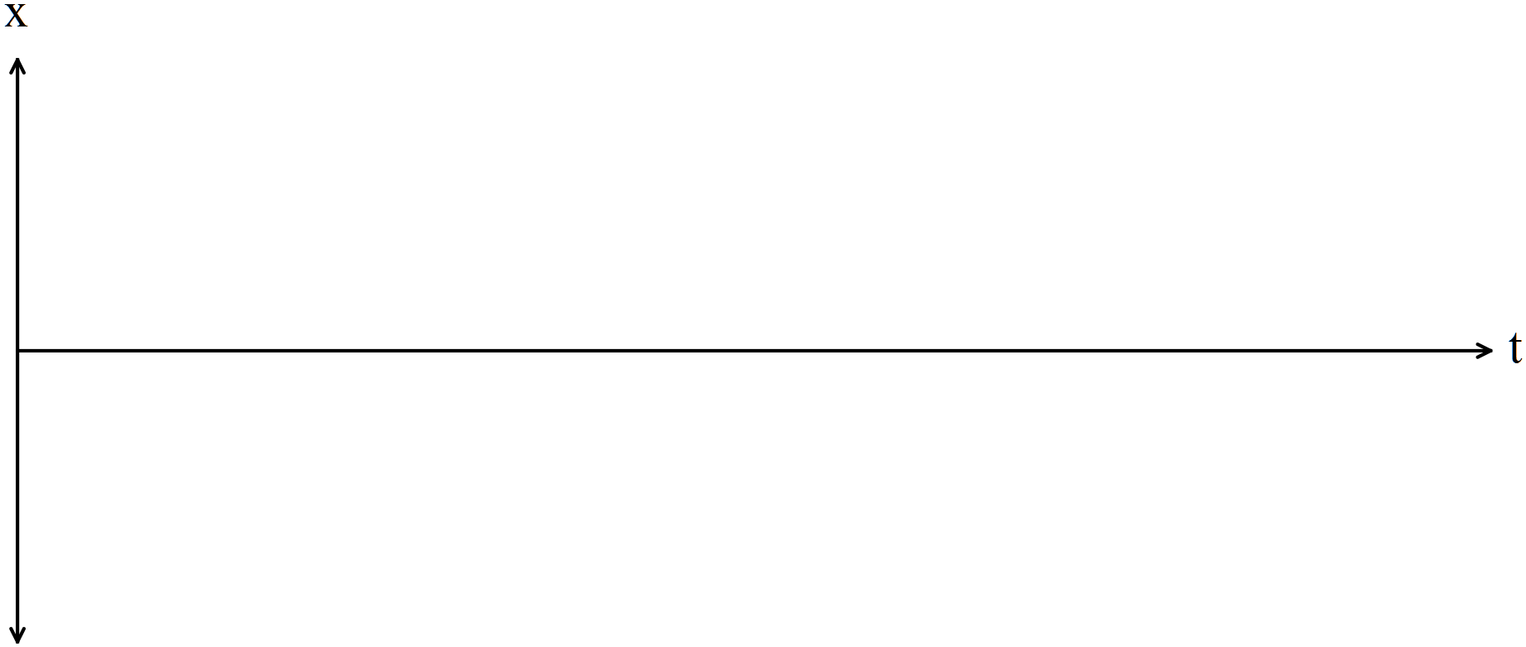

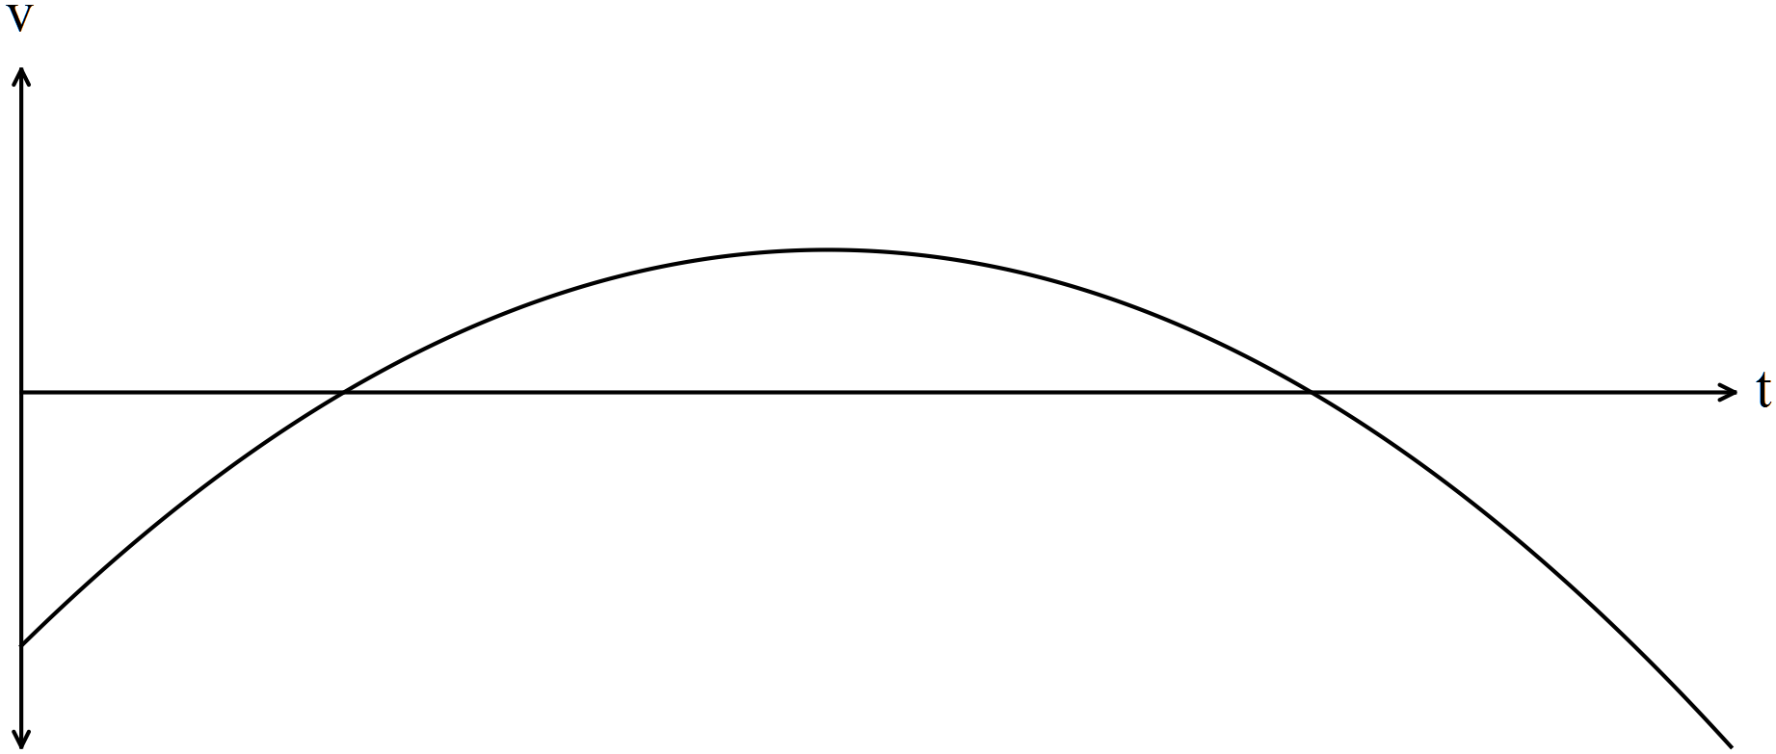

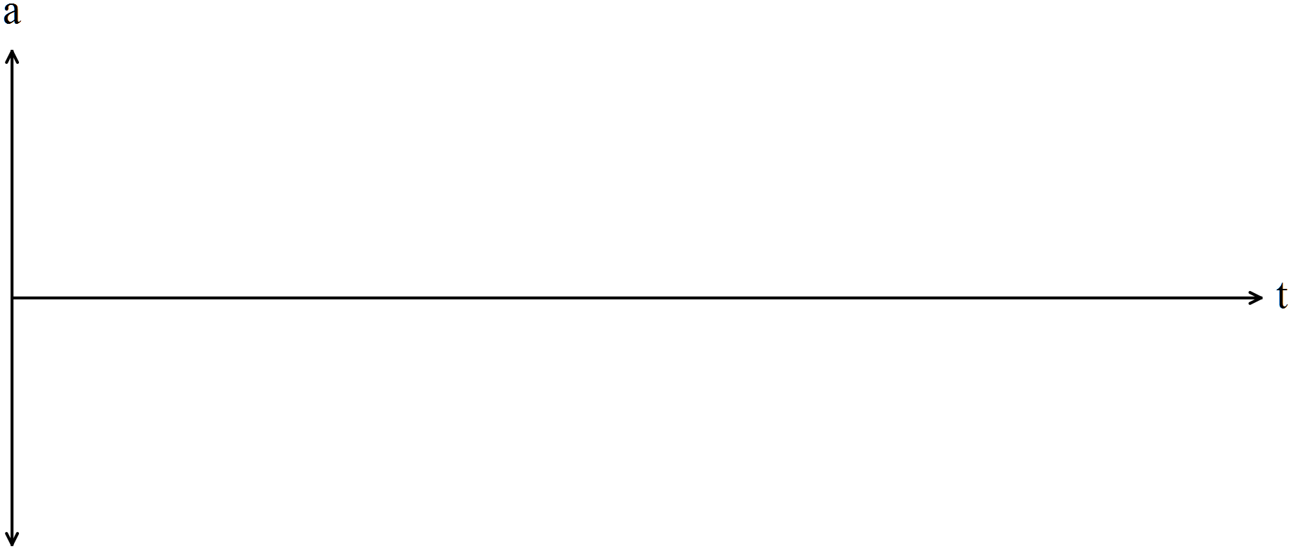

(b) State the relationship between the roots and turning point of with the

graphs of  in (a). (3 marks)

Question 10 (7 marks)

The voltage between the plates of a discharging capacitor can be modelled by the function $V\left(t\right)=14e^{kt}$, where $V$ is the voltage in volts, $t$ is the time in seconds and $k$ is a constant.

It was observed that after three minutes the voltage between the plates had decreased to 0.6 volts.

(a) State the initial voltage between the plates. (1 mark)

(b) Determine the value of $k$. (2 marks)

(c) How long did it take for the initial voltage to halve? (2 marks)

(d) At what rate was the voltage decreasing at the instant it reached 8 volts? (2 marks)

Question 11 (7 marks)

(a) Four random variables $W$, $X$, $Y$ and $Z$ are defined below. State, with reasons, whether the distribution of the random variable is Bernoulli, binomial, uniform or none of these.

(4 marks)

*The dice referred to is a cube with faces numbered with the integers 1, 2, 3, 4, 5 and 6.*

(i) $W$ is the number of throws of a dice until a six is scored.

(ii) $X$ is the score when a dice is thrown.

(iii) $Y$ is the number of odd numbers showing when a dice is thrown.

(iv) $Z$ is the total of the scores when two dice are thrown.

(b) Pegs produced by a manufacturer are known to be defective with probability $p$, independently of each other. The pegs are sold in bags of $n$ for $4.95. The random variable $X$ is the number of faulty pegs in a bag.

If $E\left(X\right)=1.8$ and $Var\left(X\right)=1.728$, determine $n$ and $p$. (3 marks)

Question 12 (9 marks)

75% of the avocados produced by a farm are known to be first grade, the rest being second grade. Trays of 24 avocados are filled at random in a packing shed and sent to market.

Let the random variable $X$ be the number of first grade avocados in a single tray.

(a) Explain why $X$ is a discrete random variable, and identify its probability distribution.

(2 marks)

(b) Calculate the mean and standard deviation of $X$. (2 marks)

(c) Determine the probability that a randomly chosen tray contains

(i) 18 first grade avocados. (1 mark)

(ii) more than 15 but less than 20 first grade avocados. (2 marks)

(d) In a random sample of 1000 trays, how many trays are likely to have fewer first grade than second grade avocados. (2 marks)

Question 13 (8 marks)

The speed, in metres per second, of a car approaching a stop sign is shown in the graph below and can be modelled by the equation $v\left(t\right)=6\left(1+\cos\left(0.25t\right)+\sin^{2}\left(0.25t\right)\right)$, where $t$ represents the time in seconds.

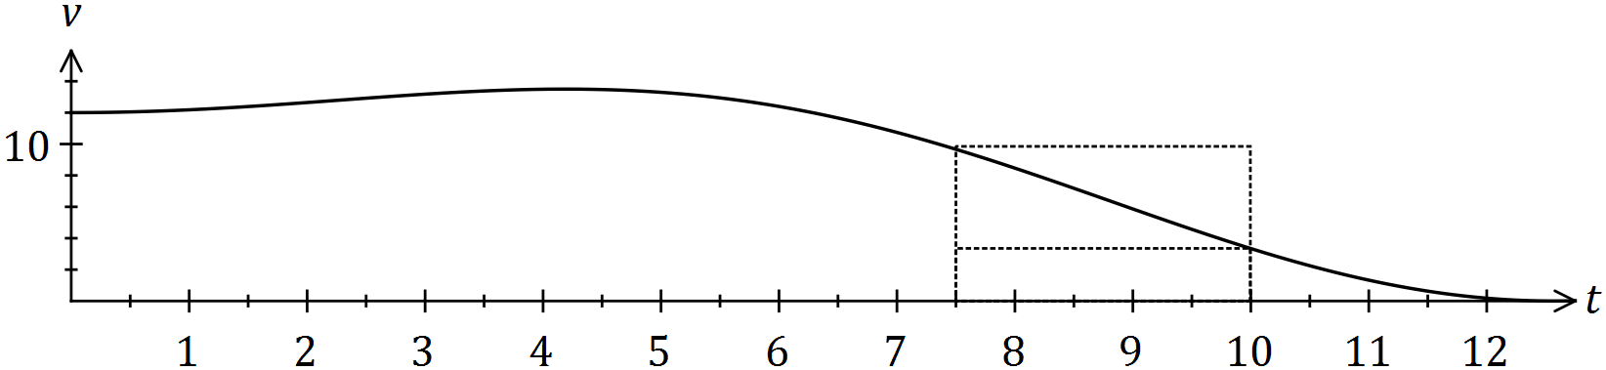

The area under the curve for any time interval represents the distance travelled by the car.

(a) Complete the table below, rounding to two decimal places. (2 marks)

|  |  |  |  |  |  |
| --- | --- | --- | --- | --- | --- |
| $$t$$ | $$0$$ | $$2.5$$ | $$5$$ | $$7.5$$ | $$10$$ |
| $$v(t)$$ |  |  |  |  | $$3.34$$ |

(b) Complete the following table and hence estimate the distance travelled by the car during the first ten seconds by calculating the mean of the sums of the inscribed areas and the circumscribed areas, using four rectangles of width 2.5 seconds.

*(The rectangles for the 7.5 to 10 second interval are shown on the graph.)* (5 marks)

|  |  |  |  |  |
| --- | --- | --- | --- | --- |
| Interval | $$0-2.5$$ | $$2.5-5$$ | $$5-7.5$$ | $$7.5-10$$ |
| Inscribed area |  |  |  | $$8.35$$ |
| Circumscribed area |  |  |  | $$24.15$$ |

(c) Suggest one change to the above procedure to improve the accuracy of the estimate.

(1 mark)

Question 14 (10 marks)

A slot machine is programmed to operate at random, making various payouts after patrons pay $2 and press a start button. The random variable $X$ is the amount of the payout, in dollars, in one play of the machine. Each payout can be assumed to be independent of other payouts.

The probability, $P$, that the machine makes a certain payout, $x$, is shown in the table below.

|  |  |  |  |  |  |  |  |  |
| --- | --- | --- | --- | --- | --- | --- | --- | --- |
| Payout ($) $x$ | 0 | 1 | 2 | 5 | 10 | 20 | 50 | 100 |
| Probability $P(X=x)$ | 0.25 | 0.45 | 0.2125 | 0.0625 | 0.0125 | 0.005 | 0.005 | 0.0025 |

(a) Determine the probability that

(i) in one play of the machine, a payout of more than $1 is made. (1 mark)

(ii) in ten plays of the machine, it makes a payout of $5 no more than once. (2 marks)

(iii) in five plays of the machine, the second payout of $1 occurs on the fifth play.

(3 marks)

(b) Calculate the mean and standard deviation of *X*. (2 marks)

(c) In the long run , what percentage of the player’s money is returned to them? (2 marks)

Question 15 (6 marks)

Let the random variable $X$ be the number of vowels in a random selection of four letters from those in the word LOGARITHM, with no letter to be chosen more than once.

(a) Complete the probability distribution of $X$ below. (1 mark)

|  |  |  |  |  |
| --- | --- | --- | --- | --- |
| $$x$$ | $$0$$ | $$1$$ | $$2$$ | $$3$$ |
| $$P(X=x)$$ | $$\frac{5}{42}$$ | $$\frac{10}{21}$$ |  | $$\frac{1}{21}$$ |

(b) Show how the probability for $P(X=1)$ was calculated. (2 marks)

(c) Determine $P(X≥1|X≤2)$. (2 marks)

Let event $A$ occur when no vowels are chosen in random selection of four letters from those in the word LOGARITHM.

(d) State $P(\overline{A})$. (1 mark)

**Question 16 (11 marks)**

The profit for the first few months of a company vary according to the function , where t represents months.

Hint: Use radians.

(a) FInd the first and second derivatives of the profit function and explain exactly

how these derivatives could help you graph the function. (6)

(b) Sketch the profit equation on the set of axes. (3)

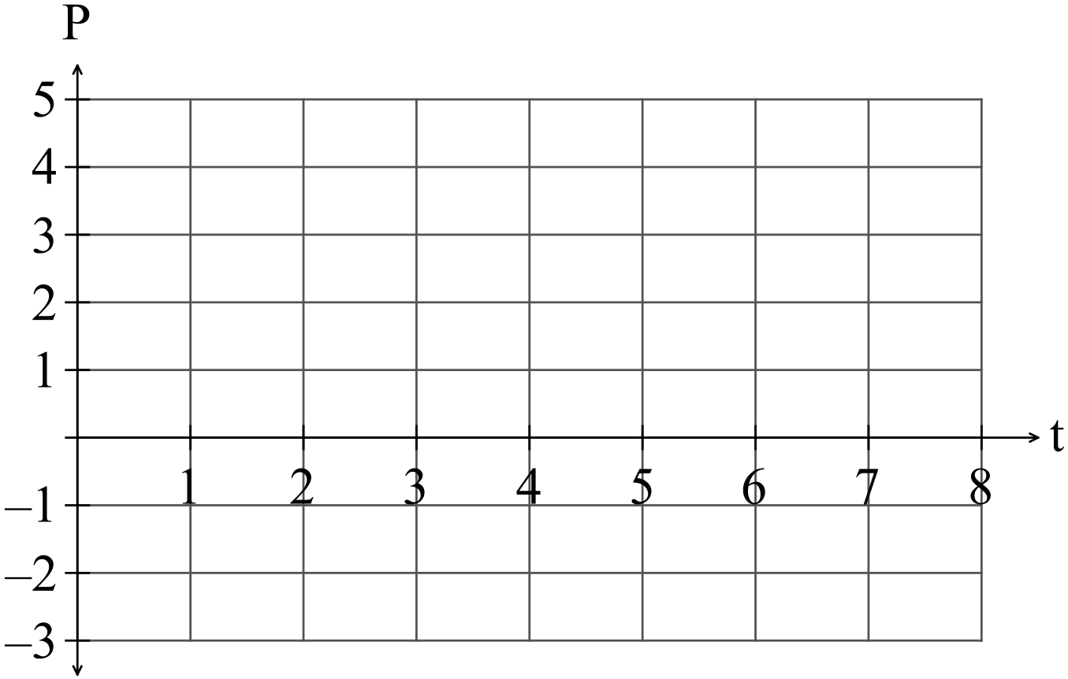

After the first two months when the profit had been increasing, the owner employed more staff and it took a little while for sales to start to increase again.

(c) Determine when the profit started to increase again. (1)

(d) Determine when the break even point was reached i.e. when profit again became positive. (1)

**Question 17 (6 marks)**

The base radius of a conical pile of sand is twice its height. If the volume of the sand is initially 60 $m^{3}$ and then another 1 $m^{3}$ of sand is added, use the increments formula to estimate the increase in the height of pile.

Quote your result in millimetres and you should assume that that radius of the cone remains twice its height.

**Question 18 (5 marks)**

(a) Given , sketch the histogram of the binomial distribution for

 on the set of axes below. (4)

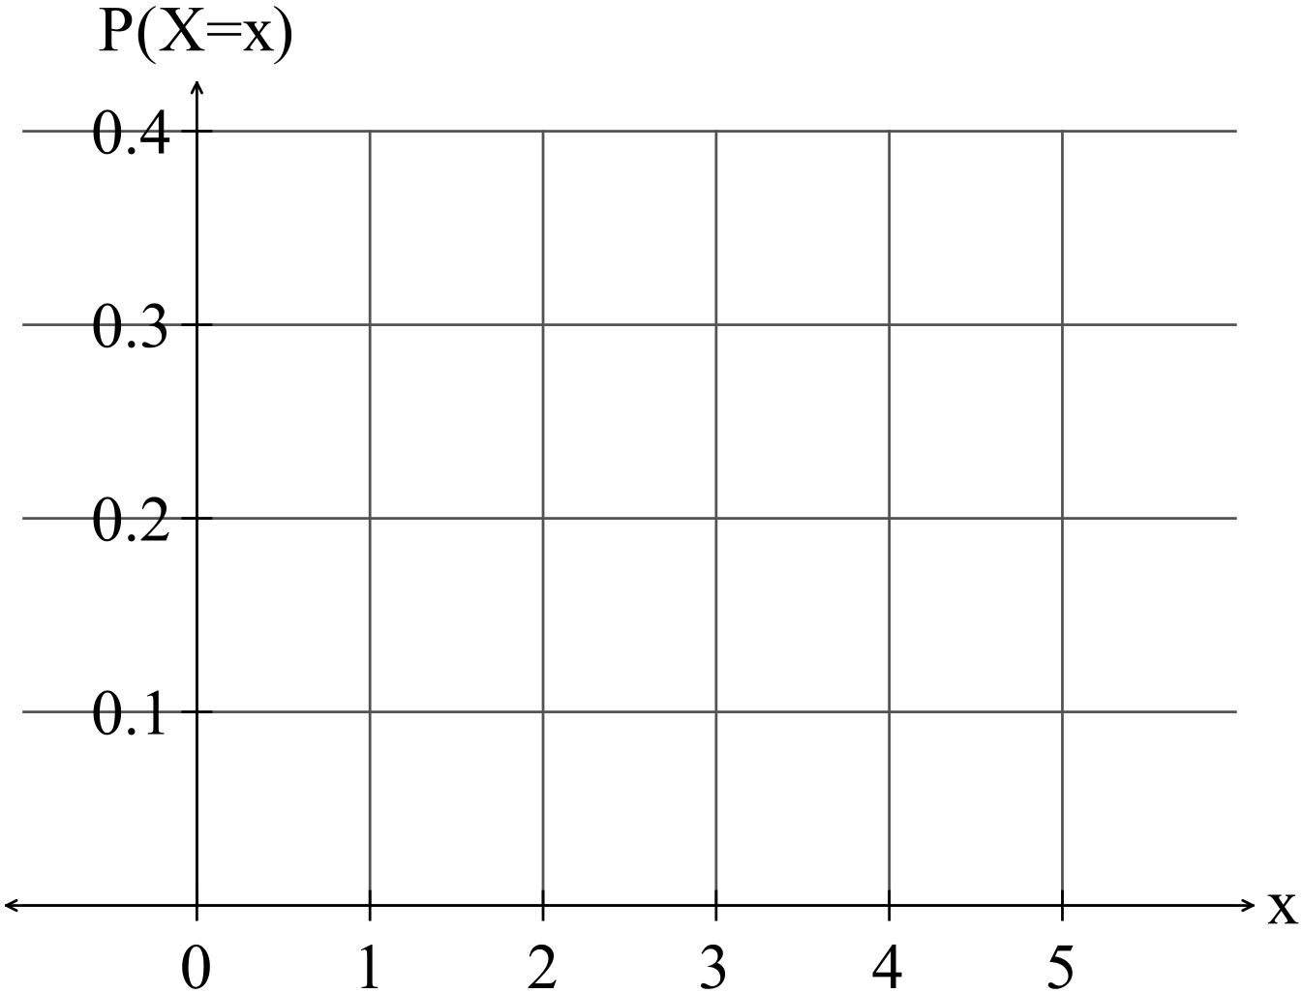

(b) Write down the value of *p* such that the skew is the same shape but in the

opposite direction. (1)

Question 19 (11 marks)

The gradient function of $f$ is given by $f^{'}(x)=12x^{3}-24x^{2}$.

(a) Show that the graph of $y=f(x)$ has two stationary points. (2 marks)

(b) Determine the interval(s) for which the graph of the function is concave upward. (3 marks)

(c) Given that the graph of $y=f(x)$ passes through $(1, 0)$, determine $f(x)$. (2 marks)

(d) Sketch the graph of $y=f(x)$, indicating all key features. (4 marks)

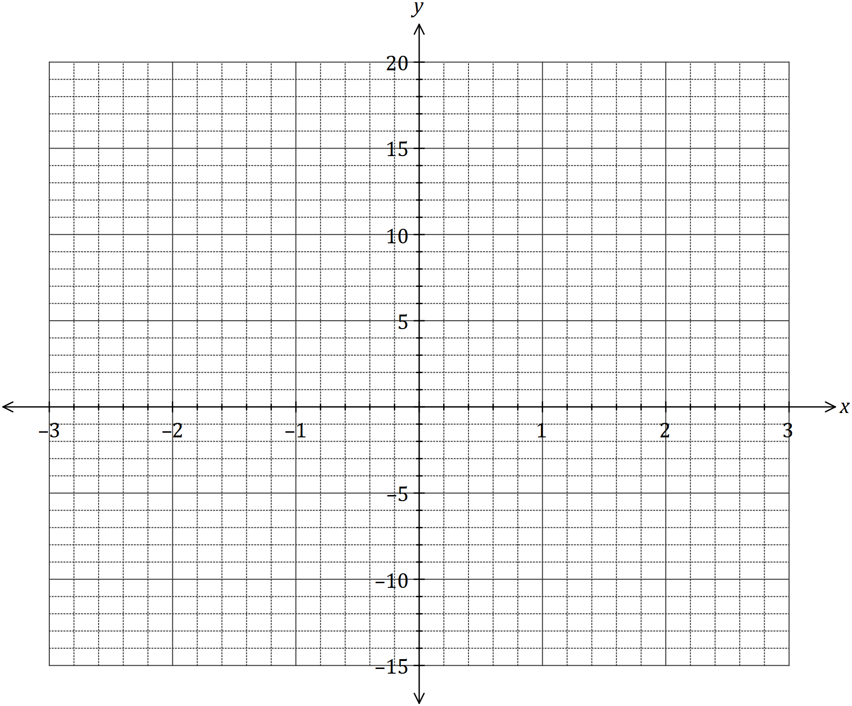

**Question 20 (9 marks)**

(a) The area of the region bounded by the curve  ,where *k* is a positive constant, the *x*-axis, and the line *x* = 9 is 27. Determine the value of *k*. (3 marks)

(b) For the domain , the curves  and  intersect at

, and  where .

(i) Determine the values of a, b and c. (3 marks)

(ii) Write down an integral to calculate the total area bounded by the two curves for the domain . (2 marks)

(iii) Evaluate the integral established in part (ii). (1 mark)

intersect when

**Question 21 (5 marks)**

In 1880, the population in the United States was 50 189 209.

In 1930, the population had increased to 123 202 624.

(a) Taking  in 1880, set up an equation in the form  that can be used to estimate the population in the United Stated during the 50 year period. (2)

(b) Write down the average annual population growth over that period. (1)

Over the next 60 years to 1990, the population grew from 123 202 624 to 248 709 873.

(c) Determine if the rate of growth during the 60 years from 1930 to 1990 is the same as the rate of growth from 1880 to 1930. (1)

**END OF QUESTIONS**

**PAGES FOR WORKING**

**PAGES FOR WORKING**

**PAGES FOR WORKING**

**PAGES FOR WORKING**

**PAGES FOR WORKING**

**PAGES FOR WORKING**

**PAGES FOR WORKING**